Name 冯柏钧 Class 1 Student ID 12011124

PART1

1. ac
2. abcd
3. 1
4. 1)The frequency response of an ideal lowpass filter is always 1 when the frequency is in the range -represented by the cutoff frequency , and always 0 while not in the range.

2)It is not a casual system because when the frequency is minus and in the range - , the frequency response is not zero.

1. b
2. 1.check whether the function of the signal has Fourier series expansion. 2.If exists, calculate the fundamental frequency and fundamental period of the signal.3. Calculate the Fourier series coefficients. 4. Define the Fourier series with synthesis equation and analysis equation.

a)

1. 1.With time domain analysis, solve the differential equation of the system.

2.With convolution, calculate the convolution of the impulse response and input signal.

8. 0

9. c

10. a) b)

PART 2

1.

1)

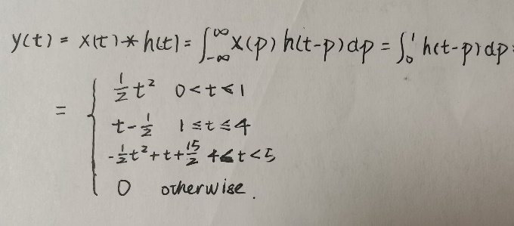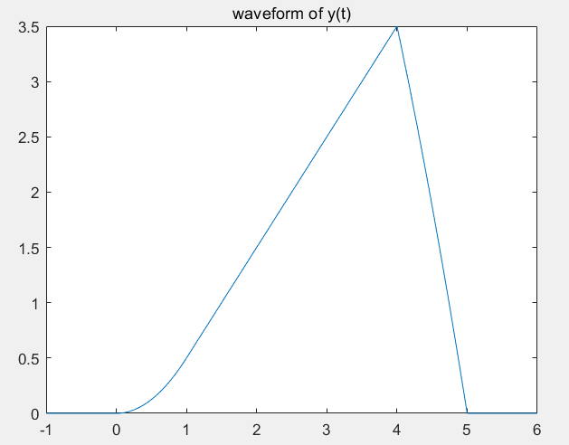

2)from the convolution theorem, the Fourier transform of the convolution of x(t) and h(t) equals the product of the Fourier transform of the x(t) and that of h(t). Calculate the product of the Fourier transform of the x(t) and that of h(t) and with mathematical transform we can get y(t).

2.

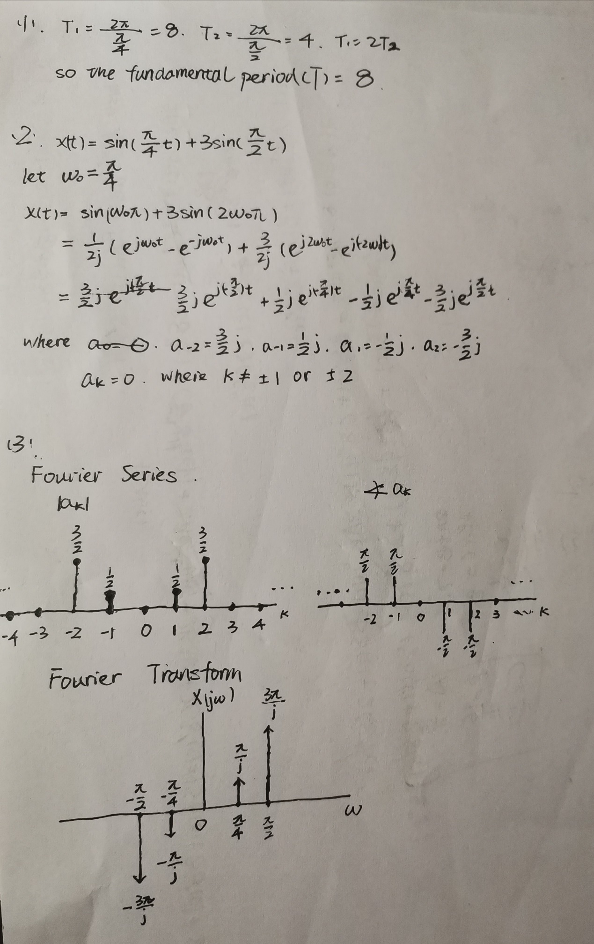

3.

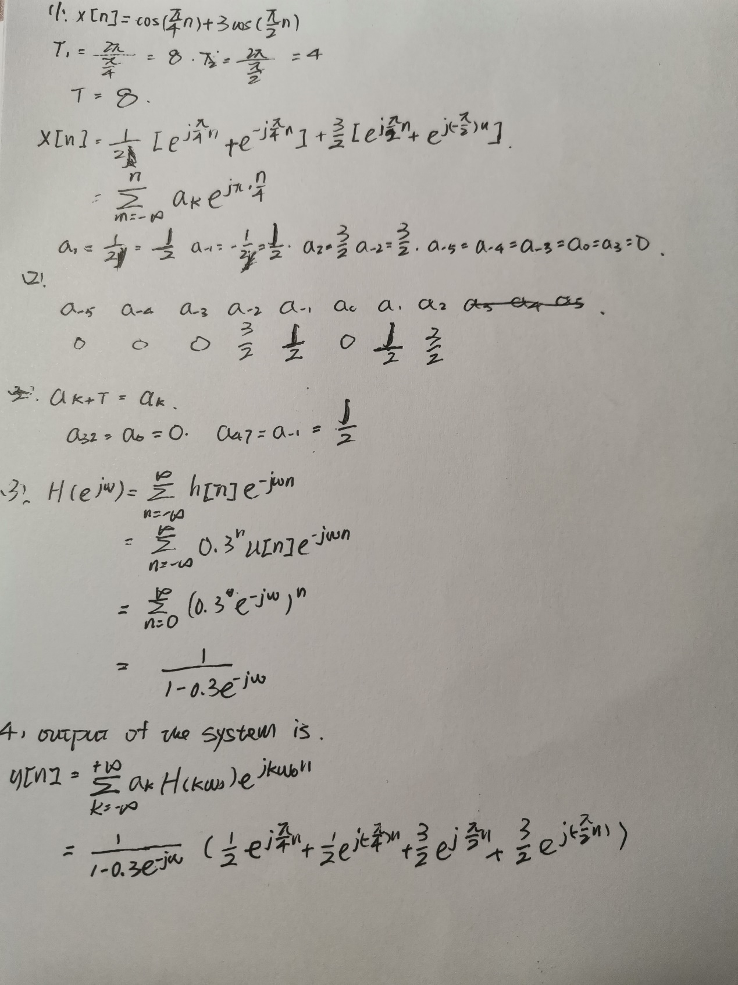

4.

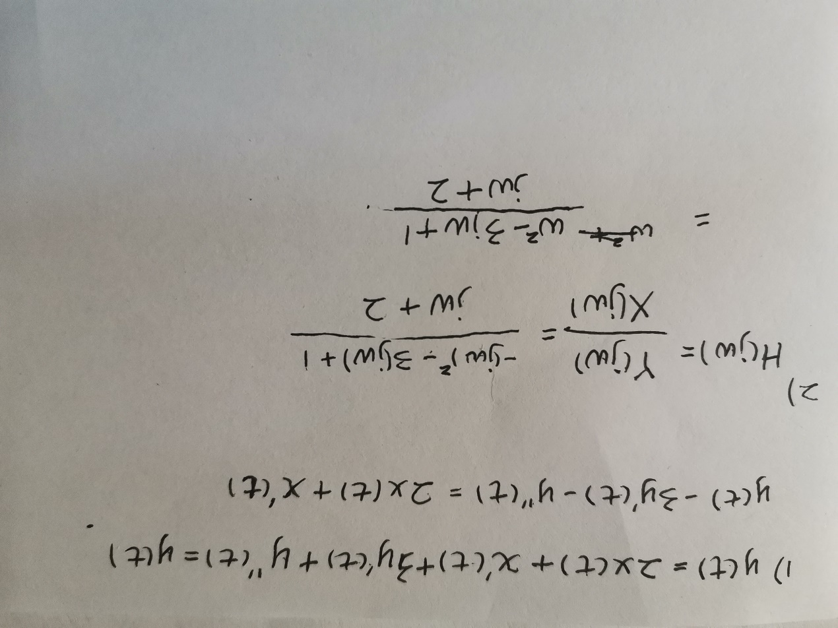

5.

